1. If we do not go for rebase, then this will happen  
   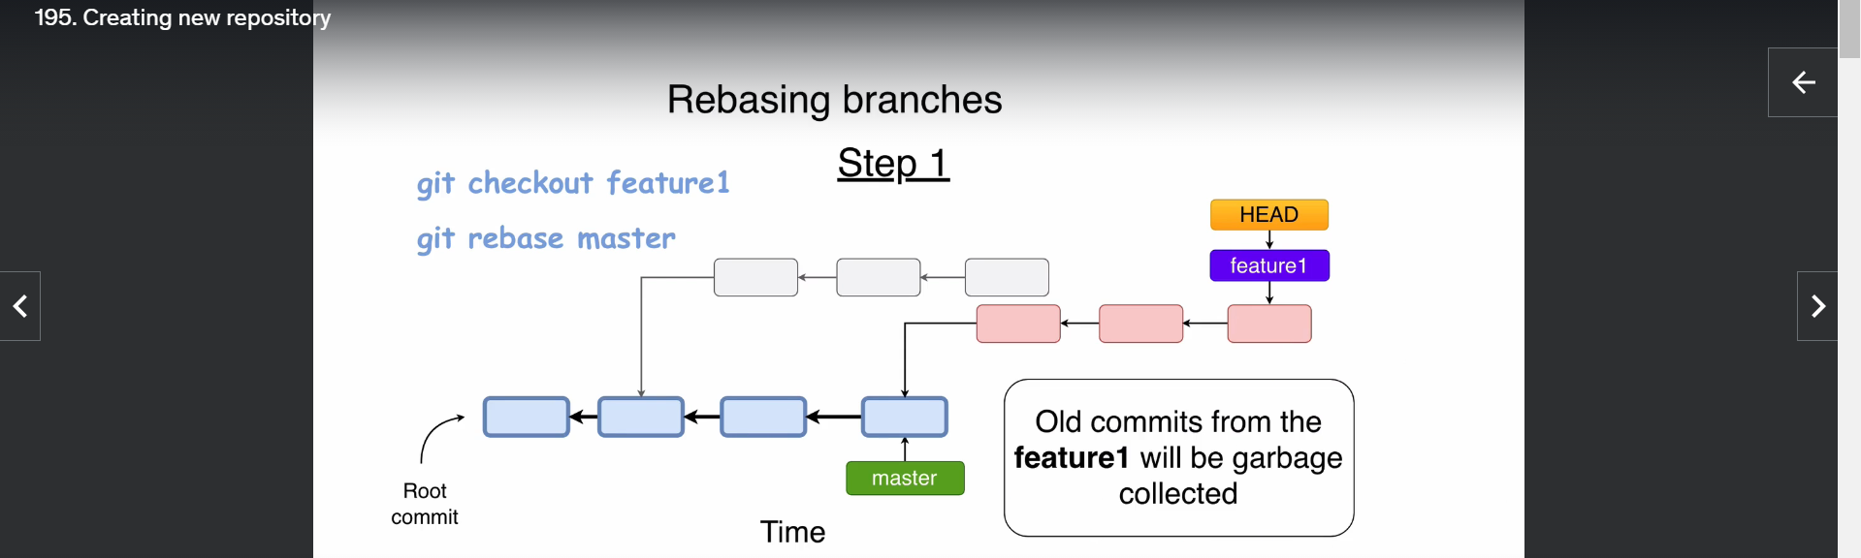
2. 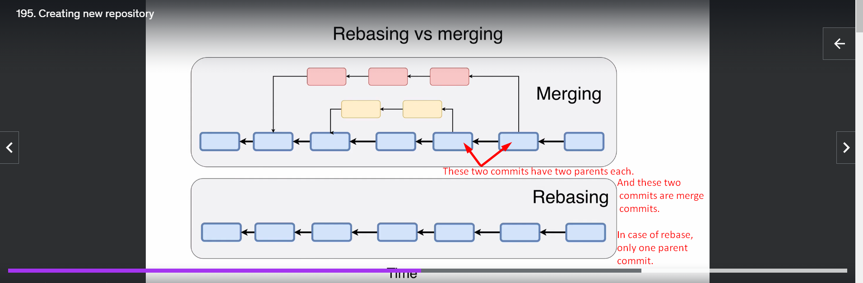
3. 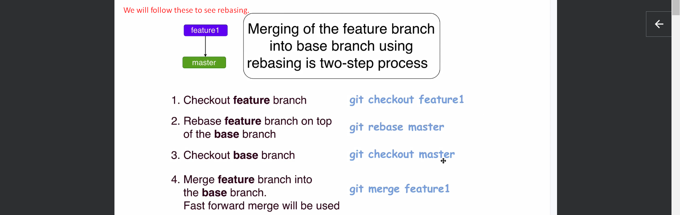
4. 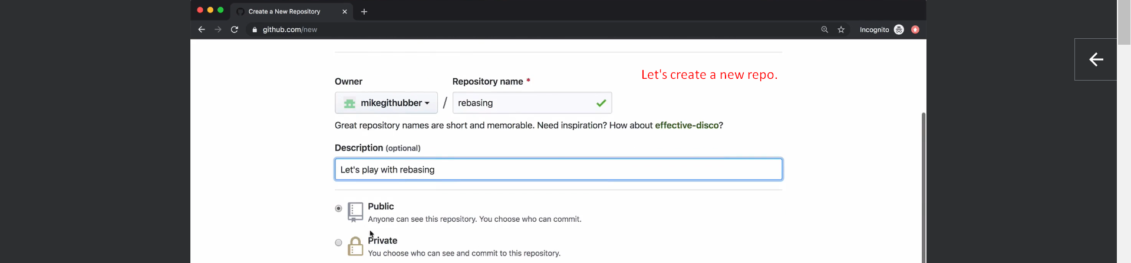
5. 